Semen Analysis Request Form
Part A: GP section (To be completed by the requesting doctor)
Nature of investigation (select option) | ☐ Infertility | ☐ Post Vasectomy | ☐ Retrograde
NHS or Private Patient (select option) | ☐ NHS ☐ Private
Patient Name (SURNAME, Forename) | Click or tap here to enter text.
Patient date of birth | Click or tap to enter a date.Click here to enter a date.
Patient address | Click or tap here to enter text.
Patient contact details (telephone/mobile and email) | Email: Click or tap here to enter text.k here to enter text.  Home/Mobile Tel: Click or tap here to enter text.Click here to
Requesting Doctor (state name) | Click or tap here to enter text.
NHS number | Click or tap here to enter text.
GP Surgery National Code | Click or tap here to enter text.
Source of referral (select option) | ☐ Bexley ☐ Southwark ☐ Other  ☐ Greenwich ☐ Lambeth …………………………  ☐ Lewisham ☐ Bromley
Hospital number | Click or tap here to enter text.
Requestor/GP Name and Full address: | Contact details for Requestor  Tel: Click or tap here to enter text.Click here to enter text.  Email (NHS.net): Click or tap here to enter text. Click here to enter t
Any other clinical details? | Click or tap here to enter text.Click here to enter text.
Requesting Doctor’s signature  (Electronic signature may be added here) | 
P.T.O for instructions to GP
Part B1: Patient section (Must be completed by all patients)
A | Date & time your sample was produced (e.g., 01.01.23) | Date: Click or tap to enter a date. |  |  | Time:
B | Date of last ejaculation (Not including today): Click or tap to enter a date.
C | Was any part of the sample lost during production? |  | No ☐ | Yes:  First part ☐ / Middle part ☐ / Last part ☐
At Synnovis, we are always looking at ways to improve the service we offer, and your feedback is extremely valuable.
We invite you to complete a short online survey. It takes ~2 minutes. If you would like to participate, select the preferred method to send the survey (or scan QR code). |  |  |  |  | Text ☐ QR code ☐  Email ☐ | No ☐
Part B2: For vasectomy patients only
Has sample been produced at least 12 weeks after surgery? |  |  |  |  | Yes ☐ | No ☐
Has sample been produced after at least 20 ejaculations? |  |  |  |  | Yes ☐ | No ☐
Part C1: Instructions for GP
Semen analysis (SEMA) kit orders:
- For more kits please continue using the online ordering portal
- Details may be found from customerservices@synnovis.co.uk. or telephone 0204 513 7300
- Each SEMA kit consists of a request form and a toxicity-tested sample container.
- Please note that the sample must be produced into the container from the SEMA kit as they have been toxicity tested. Therefore, samples produced in any other container will be rejected (as results would be invalid).

Requests and appointments:
- Please email the completed request form to Semen.Analysis@synnovis.co.uk please provide GP email address on form to ensure results are sent to correct location)
- Thereafter hand the completed form and the sample container to the patient.
- IMPORTANT: Semen analysis is by appointment only and the patient will need to telephone the laboratory for an appointment 48 hours after the form has been emailed.
- If you require an interpreter, please inform the team at the time of booking your appointment as this arrangement will need to be made in advance.

Patient test results
The semen analysis results are normally available within 10 working from date of receipt and sent via email to the clinician that requested the test.
If the clinician has not received the results, email: Semen.Analysis@synnovis.co.uk
Part C2: Instructions for patients

Please note you must book an appointment; allow 48hrs after your GP gives you this form
Clinic open: Monday-Friday (excluding bank holidays): 9:00 am – 4:15pm (samples without appointment will be rejected)
To book an appointment please call 02071882941 / 02071887740
The appointment line is open Monday-Friday (excluding bank holidays): 9am – 5pm

Producing a semen sample (please read through carefully):

- You should not have intercourse or masturbate for 2-7 days before producing your sample – as this can affect the quality of your sample.
- Your genitalia and hands should be clean but do not use soap, lubricant or condoms while producing your sample. Samples should be produced by masturbation (stimulation by hand) only. Ensure the entire specimen is collected into the specimen container from the SEMA kit.
The sample container must be from a container provided by the Synnovis Cytology lab (weight and batch number written on a Synnovis label). Other containers will be rejected.
- If you produce the sample at home: the specimen should be delivered to the semen analysis clinic at your appointment time (Location A-see map on page 4) ideally within 30-50 minutes of production. The container should be kept warm (such as in your trouser or inside jacket pocket). Ensure your name and date of birth are written on the container.
If you are unable to deliver your sample within 50 minutes of production: please inform the booking person. If required, an appointment can be made for you to produce a sample in a private room on-site: (Location B: see map on page 4).
- Please arrive at the clinic on the appointed time. All samples will be checked at the lab and therefore an appointment is necessary. Please ensure that you have an appointment.
- The results should be available to the requesting clinician within 10 working days of receipt. Test results or clinical advice can only be given by your clinician.

Information for Retrograde ejaculation investigation only:
If retrograde analysis is required (from W.H.O lab manual 2021 6th edition guidance)
Both a semen and urine sample (separate containers) are recommended when producing samples for a retrograde assessment. The patient is advised to do the following:
Step 1: Produce an ejaculate (semen) by masturbation into the 60ml Synnovis-labelled container.
Step 2: Soon afterwards urinate into the other empty specimen container (can be a 30ml or 60 ml container).

Information for Post Vasectomy Analysis only:

- The test must take place after:
- a minimum of 12 weeks after surgery, and
- a minimum of 20 ejaculations.

The test results may not be reliable if samples are produced earlier.

- Your referring doctor will provide you with clinical advice or clearance.
- The sample must be produced according to the above guidelines.
Your semen analysis result will be sent to your requesting GP/Hospital as advised above.

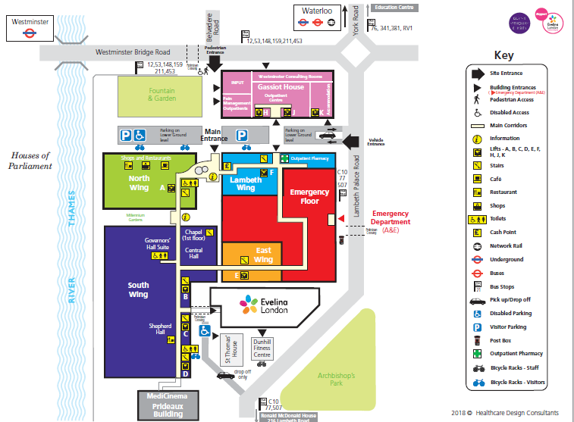
St Thomas’ Hospital Site Map

Location B
On-site sample production room (by appointment):

Gassiot House
Outpatients Centre
Ground Flour, Pink Zone
St Thomas’ Hospital
Westminster Bridge Road
London
SE1 7EH

Location A
Take your sample here (by appointment):

Semen Analysis Clinic
Cytology Department
2nd Floor, North Wing
St Thomas’ Hospital
Westminster Bridge Road
London
SE1 7EH

Location B

Location A

